Students Enjoy Breakfast in the Bluegrass
By Erin Gibbons
Posted: June 6, 2012
Wayne County Middle School (WCMS) in Monticello, Kentucky, celebrated March's National Nutrition Month in a unique way this year. With the help of grant funding from the Action for Healthy Kids-Kellogg's School Breakfast to School Wellness partnership, WCMS launched a "Breakfast in the Bluegrass" campaign with the goal of increasing participation in its breakfast program. Thanks to a joint effort between teachers, staff and students, more than half of WCMS students are now eating school breakfast, a 12 percent increase from earlier in the school year.
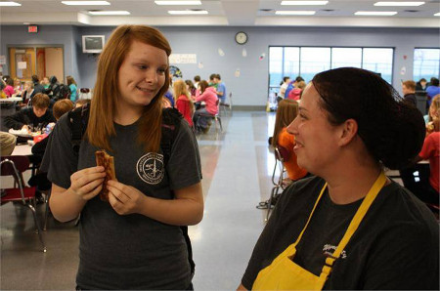
Teachers and school nutrition officials knew that kids who eat school breakfast perform better academically and consume more milk and fruits than those who eat breakfast elsewhere, and they wanted more students to "join the breakfast club." After a survey found that 50 percent of the kids didn't like the food being offered, it was clear that more student input was needed. So, during the week of March 19, students got the opportunity to sample new breakfast foods, such as whole-grain breakfast cookies, mini waffles and Grab N' Go. After "taste testing" each new item, they were able to indicate whether they liked it on a display posted in the cafeteria.
"Taste testing was a hit with students, and as we implemented the popular items into the menus, students found that we appreciated their voices," says Karen Gibson, WCMS's food service director and a registered dietitian. "We heard students talk more favorably about the foods offered and how the lunch ladies really did listen to them."
Seventh-grader Hannah Stonewall said she isn't hungry and is in a better mood because of the school breakfast program. "I like the new Grab N' Go menu options that [have been] offered lately, which make it easier to take with you," she explains.
The school also held a pep rally for school breakfast with mascot "Ms. Bluegrass Breakfast" and created incentives for breakfast participation, such as giving kids who ate breakfast three times a week special dress-up days and "Activity Fridays." Students did their part, too, incorporating messages about the benefits of breakfast into the school's morning announcements. The combined efforts have had a positive impact.
"The students have worked really hard on the campaign," Gibson said. "The greatest difference in participation has been with student involvement and integrating their input into the breakfast program."

Keep Kids Healthy

Spread The Word
Help us fight and prevent childhood obesity.
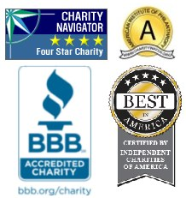
ABOUT SSL CERTIFICATES

Share Your Story
Send in how you’re making kids and schools healthier.
More Sharing ServicesShare|Share on facebookShare on myspaceShare on googleShare on twitter

Check Out Our Other Sites
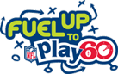
nonprofit software
- Contact Us |
- Donate |
- Site Map |
- Privacy Policy
© 2011 Action for Healthy Kids • 501(C)3

